Практическая работа 6
Тема: «Достоверность информационных систем»

Цель: освоение методов обеспечения и контроля качества программного обеспечения на практике путем разработки тестируемого приложения сетевого терминала с применением принципов модульного тестирования, контроля ошибок и пользовательского тестирования.

Ход работы

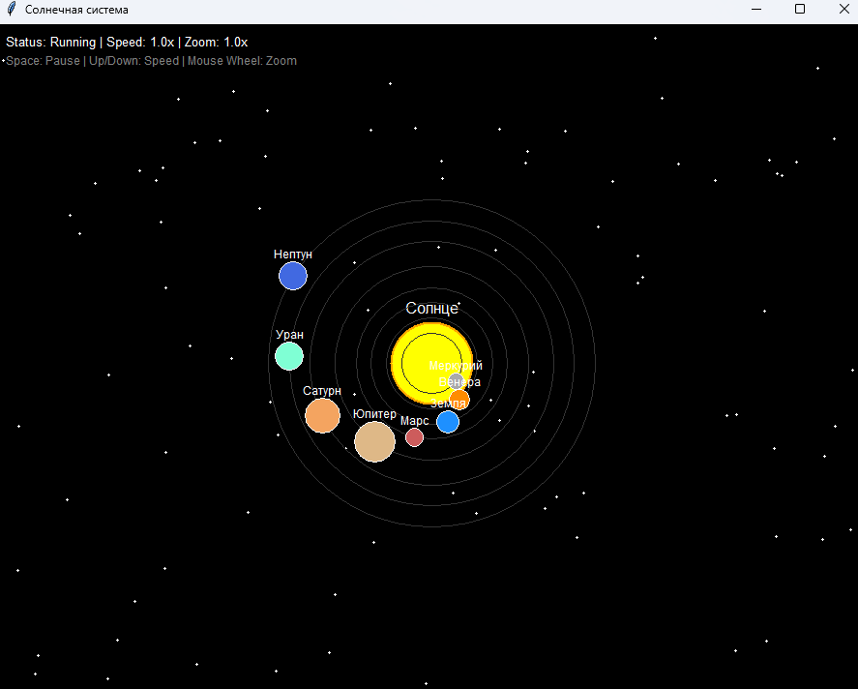
Рис. 1 – Начальный экран

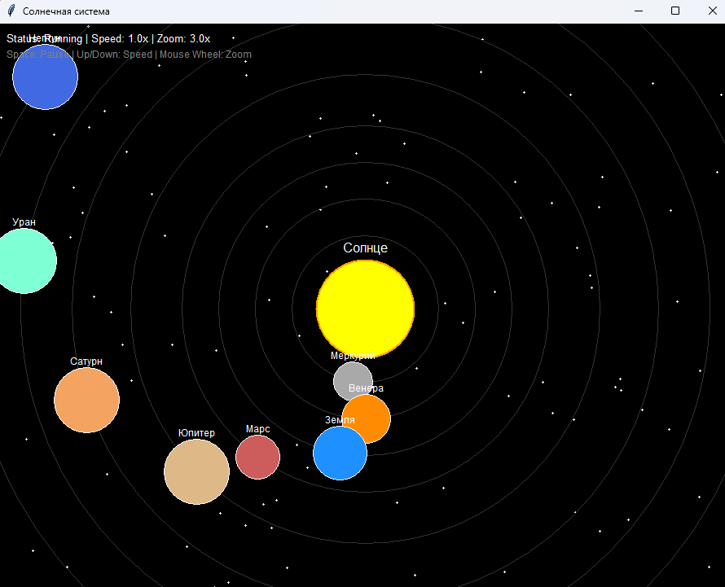
Рис. 2 – Максимальное приближение

Функцию остановки и ускорения можно будет увидеть на прикрепленном видео

Приложение А:
import tkinter as tk
import math

class Planet:
def __init__(self, name, orbit_radius, speed, size, color, start_angle):
self.name = name
self.orbit_radius = orbit_radius
self.speed = speed
self.size = size
self.color = color
self.angle = math.radians(start_angle)

class SolarSystemApp:
def __init__(self, root):
self.root = root
self.root.title("Солнечная система")
self.root.geometry("900x700")

self.canvas = tk.Canvas(self.root, bg='black', highlightthickness=0)
self.canvas.pack(fill=tk.BOTH, expand=True)

self.center_x = self.root.winfo_width() // 2
self.center_y = self.root.winfo_height() // 2
self.zoom = 1.0
self.speed_multiplier = 1.0
self.paused = False
self.base_scale = 30

self.planets = []
self.init_planets()

self.root.bind('<Configure>', self.on_resize)
self.root.bind('<MouseWheel>', self.on_mousewheel)
self.root.bind('<space>', self.toggle_pause)
self.root.bind('<Up>', self.increase_speed)
self.root.bind('<Down>', self.decrease_speed)

self.animate()

def init_planets(self):
self.planets = [
Planet("Меркурий", 1.0, 0.05, 8, '#A9A9A9', 0),
Planet("Венера", 1.5, 0.03, 10, '#FF8C00', 30),
Planet("Земля", 2.0, 0.02, 11, '#1E90FF', 60),
Planet("Марс", 2.5, 0.018, 9, '#CD5C5C', 90),
Planet("Юпитер", 3.2, 0.008, 20, '#DEB887', 120),
Planet("Сатурн", 4.0, 0.006, 17, '#F4A460', 150),
Planet("Уран", 4.7, 0.004, 14, '#7FFFD4', 180),
Planet("Нептун", 5.4, 0.003, 14, '#4169E1', 210)
]

def on_resize(self, event):
self.center_x = self.canvas.winfo_width() // 2
self.center_y = self.canvas.winfo_height() // 2

def on_mousewheel(self, event):
if event.delta > 0:
self.zoom *= 1.1
else:
self.zoom *= 0.9
self.zoom = max(0.3, min(3.0, self.zoom))

def toggle_pause(self, event):
self.paused = not self.paused

def increase_speed(self, event):
self.speed_multiplier *= 1.2

def decrease_speed(self, event):
self.speed_multiplier *= 0.8

def draw_stars(self):
import random
for _ in range(100):
x = random.randint(0, self.canvas.winfo_width())
y = random.randint(0, self.canvas.winfo_height())
self.canvas.create_oval(x, y, x+2, y+2, fill='white', outline='')

def draw_sun(self):
sun_size = max(10, min(60, 40 * self.zoom))
x0 = self.center_x - sun_size
y0 = self.center_y - sun_size
x1 = self.center_x + sun_size
y1 = self.center_y + sun_size
self.canvas.create_oval(x0, y0, x1, y1, fill='yellow', outline='orange', width=2)
self.canvas.create_text(self.center_x, self.center_y - sun_size - 15, text='Солнце', fill='white', font=('Arial', 12))

def draw_orbits(self):
for planet in self.planets:
radius = planet.orbit_radius * self.base_scale * self.zoom
if radius < 10:
continue
x0 = self.center_x - radius
y0 = self.center_y - radius
x1 = self.center_x + radius
y1 = self.center_y + radius
self.canvas.create_oval(x0, y0, x1, y1, outline='#333333', width=1)

def draw_planets(self):
for planet in self.planets:
if not self.paused:
planet.angle += planet.speed * self.speed_multiplier * 0.02

radius = planet.orbit_radius * self.base_scale * self.zoom
x = self.center_x + math.cos(planet.angle) * radius
y = self.center_y + math.sin(planet.angle) * radius

size = max(4, min(40, planet.size * self.zoom))

x0 = x - size
y0 = y - size
x1 = x + size
y1 = y + size

self.canvas.create_oval(x0, y0, x1, y1, fill=planet.color, outline='white', width=1)
self.canvas.create_text(x, y - size - 8, text=planet.name, fill='white', font=('Arial', 9))

def draw_ui(self):
status = "Paused" if self.paused else "Running"
info = f"Status: {status} | Speed: {self.speed_multiplier:.1f}x | Zoom: {self.zoom:.1f}x"
self.canvas.create_text(10, 10, text=info, fill='white', anchor='nw', font=('Arial', 10))
self.canvas.create_text(10, 30, text="Space: Pause | Up/Down: Speed | Mouse Wheel: Zoom", fill='gray', anchor='nw', font=('Arial', 9))

def animate(self):
self.canvas.delete('all')
self.draw_stars()
self.draw_sun()
self.draw_orbits()
self.draw_planets()
self.draw_ui()
self.root.after(20, self.animate)

if __name__ == "__main__":
root = tk.Tk()
app = SolarSystemApp(root)
root.mainloop()

